Write a Python Program to Implement Depth-First Search (DFS)
AIM:
To write a Python program to implement the Depth-First Search (DFS) algorithm for graph traversal.

Objective
To traverse all the nodes of a graph using the Depth-First Search (DFS) algorithm.

Algorithm
- Start.
- Create a graph using an adjacency list.
- Select the starting node.
- Push the starting node onto the stack.
- Pop a node from the stack.
- If the node is not visited, display it and mark it as visited.
- Push all unvisited adjacent nodes onto the stack.
- Repeat Steps 5–7 until the stack becomes empty.
- Stop.
FLOWCHART:
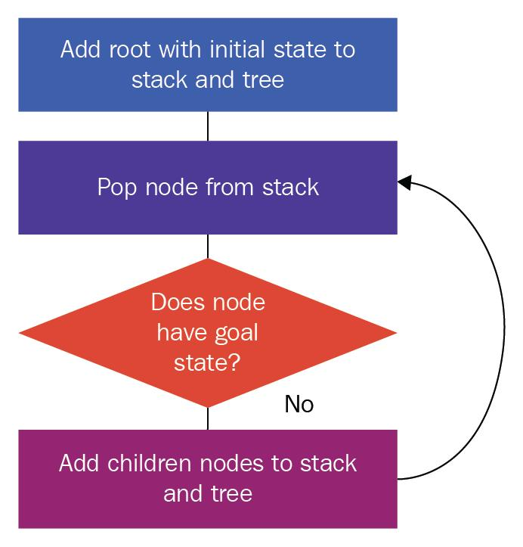
CODE:
graph = {
'A': ['B', 'C'],
'B': ['D', 'E'],
'C': ['F'],
'D': [],
'E': ['F'],
'F': []
}

visited = set()
stack = ['A']

while stack:
node = stack.pop()

if node not in visited:
print(node, end=" ")
visited.add(node)

for neighbor in reversed(graph[node]):
if neighbor not in visited:
stack.append(neighbor)
RESULT:
The Python program successfully traversed all the nodes of the graph using the Depth-First Search (DFS) algorithm.

Conclusion
The Depth-First Search (DFS) algorithm was successfully implemented in Python. The graph was traversed by exploring one branch completely before moving to the next, demonstrating the use of a stack for graph traversal in Artificial Intelligence.

